# Document Overview

The table in the *Why Why Diagram: Needs Overviews* section outlines the needs and their underlying causes. See the corresponding section in *Needs Research* for supporting research and sources.

# Why Why Diagrams: Needs Overviews

|  |  |  |  |
| --- | --- | --- | --- |
|  | **Need** | **Why** | **Why** |
| I | A way to ensure collected material is recyclable | Material may be contaminated | Material is not properly cleaned; recycling is not filtered to remove biohazards |
| II | A way to ensure waste is properly sorted such that all materials that can be recycled are | People are misinformed about how to sort their waste | Different jurisdictions have different regulations; lack of attainable information; lack of motivation to self-educate |
| III | A way to properly dismantle cars and large appliances such that the plastics can be recycled | Metal is extracted from these machines, and then the rest is shredded | It is more cost effective / less labour intensive to shred the rest of the machine |
| IV | A way to make recycling more accessible to the average consumer | Consumers cite lack of time to sort recycling | Many consumers have to sort and take recycling to a centre |

# Needs Research

Below is the research corresponding to the above needs.

1. **Ensure collected material is recyclable**
   1. Only a fraction of materials collected is acutally recycled due to contamination, infrastructure deficiencies and lack of markets ([Proposed Integrated Management Approach to Plastic Products](https://www.canada.ca/en/environment-climate-change/services/canadian-environmental-protection-act-registry/plastics-proposed-integrated-management-approach.html#toc2))
   2. 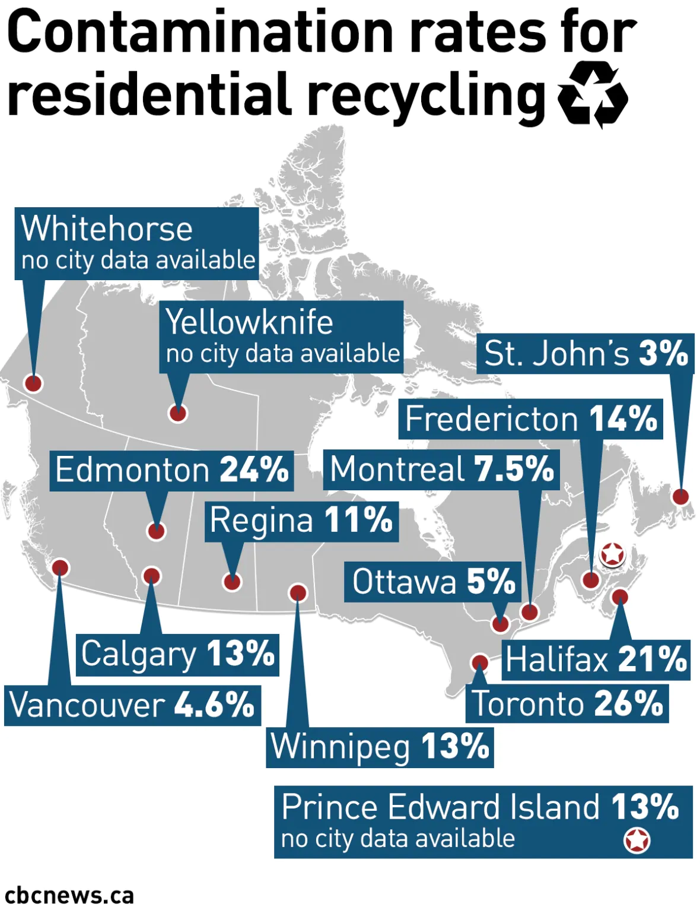([CBC](https://www.cbc.ca/news/technology/recycling-contamination-1.4606893))
   3. Estimates state that for every 1% of reduced contamination, it could save the City of Toronto $0.6-1 million / year because contaminated materail is processed as recycling only to be sent to the dump, and as it moves through the system, it could contaminate other recyclables ([CBC](https://www.cbc.ca/news/technology/recycling-contamination-1.4606893))
   4. China (a large importer of recycled paper) recently updated its standards such that paper with more than 0.5% contamination is unnacceptable – this is hard for Canada to reach
   5. Biohazards require the entire plant to be shut down and sanitized, which is very expensive ([CBC](https://www.cbc.ca/news/technology/recycling-contamination-1.4606893))
   6. Discluding common contaminants such as glass and styrofoam help reduce overall contamination cost
   7. The Recycling Partnership identifies the 5 most common curbside contaminants: tanglers, film plastic, bagged objects, hazardous materials, food/biohazards ([Heavy Toll of Contaminants](https://www.recyclingtoday.com/article/the-heavy-toll-of-contamination/))
   8. When food/liquids enter the recycling, this saturate otherwise good paper/cardboard and reduces quality/increase chance of rejection ([Waste Management](https://mediaroom.wm.com/the-battle-against-recycling-contamination-is-everyones-battle/))
   9. Municipal recycling systems often rate contamination of waste as a percentage of total weight of the recycled material; however, this does not accurately reflect the cost of the contamination as a large portion of it comes from light weight items like tangles, and film plastic. There needs to be a better metric (like frequency) for contamination and some way to enforce/encourage it ([Heavy Toll of Contaminants](https://www.recyclingtoday.com/article/the-heavy-toll-of-contamination/))
   10. 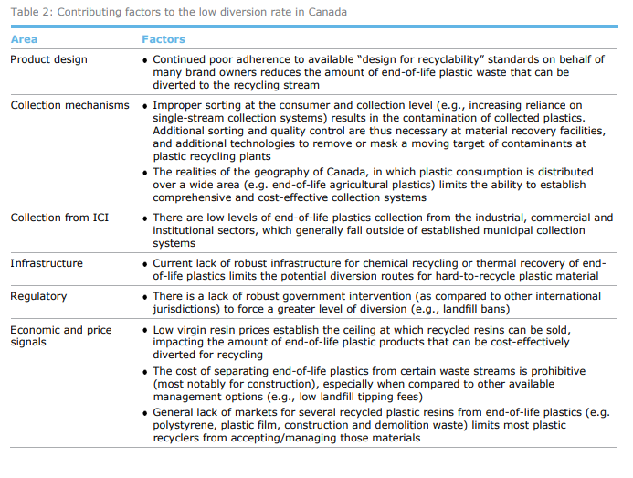([Economic Study of the Canadian Plastic Industry, Markets and Waste](http://publications.gc.ca/collections/collection_2019/eccc/En4-366-1-2019-eng.pdf))
2. **Ensure waste is properly sorted / can be sorted easily**
   1. Problems
      1. A South African study notes lack of knowledge on how to recycle and how to sort as one of the five most common barriers to recycling: “Knowledge of the recycling program, awareness of the location of recycling facilities, and knowing how to and knowing what materials are recyclable is needed. Well targeted communications, door-to-door promotions, regular information and feedback including “how to” messages is needed to improve recycling. The visibility of recycling bins reminds people to put recyclables out” ([Natural Resources and the Environment](https://www-scopus-com.proxy.lib.uwaterloo.ca/record/display.uri?eid=2-s2.0-85071981026&origin=resultslist&sort=plf-f&src=s&st1=&st2=&sid=b415d024633652da9767886a2e82e8d5&sot=b&sdt=b&sl=41&s=TITLE-ABS-KEY+%28why+people+do+not+recycle%29&relpos=1&citeCnt=10&searchTerm=))
      2. According to Forbes, 92% of Americans are unsure of whether they can recycle certain plastics, and 74% agreed recycling would be easier with a unified system ([Forbes](https://www.forbes.com/sites/jeffkart/2019/04/15/you-may-be-contaminating-your-recycle-bin-with-non-recyclables/?sh=3a12366e313c))
      3. Mixing recycling increases the cost to process recyclables + the price of recyclables has dropped; this creates a large economic barrier that disincentivizes recycling ([Waste Management](https://mediaroom.wm.com/the-battle-against-recycling-contamination-is-everyones-battle/))
   2. Existing Solutions
      1. **Automatic Sorting;** An *Automatic Recycling System*  has been designed for the automatic sorting of plastic bottles, almunium cans and carboard cups by researchers at the Catholic University of Colombia ([Design of Automatic Recycling System Phase I](https://ieeexplore-ieee-org.proxy.lib.uwaterloo.ca/document/9240224/authors#authors)):

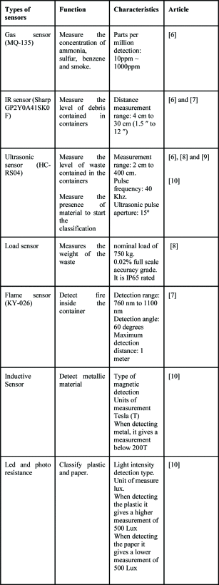

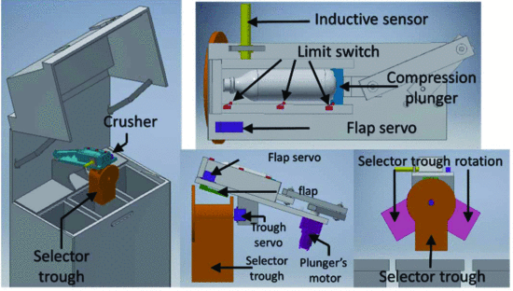

* + 1. **Education Programmes:** municipal information distribution to consumers on how to properly sort recycling ([Waste Management](https://mediaroom.wm.com/the-battle-against-recycling-contamination-is-everyones-battle/))

1. **Create a way to dismantle industrial appliances**
   1. Plastic is collected but discarded; in the automotive and white good sector, usually the only cost-effective material of interest is metal; the recyclable plastic in these appliances is then crushed and shredded because it is more cost effective ([Economic Study of the Canadian Plastic Industry, Markets and Waste](http://publications.gc.ca/collections/collection_2019/eccc/En4-366-1-2019-eng.pdf))
2. **Ensure recycling is more accessible to the average consumer**
   1. A South African study notes lack of lack of time and inconvenient facilities as one of the five most common barriers to recycling: “There is an issue of time associated with recycling especially when having to take recyclable materials to a drop-off site. People with more time is more likely to take recyclables to drop-off facilities. Working people have less time to recycle than retired individuals. Access to good recycling facilities encourages recycling behavior. A good recycling service is reliable, convenient, and easy to use. Improving recycling schemes to suit household preferences has greater potential to positively change householders’ recycling behavior than either incentives or penalties.” ([Natural Resources and the Environment](https://www-scopus-com.proxy.lib.uwaterloo.ca/record/display.uri?eid=2-s2.0-85071981026&origin=resultslist&sort=plf-f&src=s&st1=&st2=&sid=b415d024633652da9767886a2e82e8d5&sot=b&sdt=b&sl=41&s=TITLE-ABS-KEY+%28why+people+do+not+recycle%29&relpos=1&citeCnt=10&searchTerm=))
   2. This is an issue in rural Canada where curbside pickup is not available ([Economic Study of the Canadian Plastic Industry, Markets and Waste](http://publications.gc.ca/collections/collection_2019/eccc/En4-366-1-2019-eng.pdf))
   3. Northern and remote communities are challenges by climate, population size and access to services/facilities. The techniques/systems used by Canadian cities are not necessarily applicable to remote communities. It is often not economically profitable to recycle or have proper waste management. Some communities have pooled together to put their wastee in a collective center. ([Solid Waste Management for Northern and Remote Communities](http://publications.gc.ca/collections/collection_2017/eccc/En14-263-2016-eng.pdf))
   4. Across Canada, people without curbside pickup are less likely (92% vs 98%) to recycle, particularly in communities where recycling depots are hard to access. This does not hold true where recycling depots are the norm, like in Nfld ([Recycling By Canadian Households](https://www150.statcan.gc.ca/n1/pub/16-001-m/2010013/part-partie1-eng.htm#:~:text=This%20relationship%20was%20again%20seen,%2C%20respectively%2C%20for%20Alberta).))
   5. Residents in apartments rather than single-detached homes in Canada are less likely to recycle, perhaps because chutes do not offer recycling options ([Recycling By Canadian Households](https://www150.statcan.gc.ca/n1/pub/16-001-m/2010013/part-partie1-eng.htm#:~:text=This%20relationship%20was%20again%20seen,%2C%20respectively%2C%20for%20Alberta).))

# General Need for Recycling Innovation

1. 25% of plastics are collected and sent to recycling facilities in Canada as compared to the 100% target by 2030 ([Proposed Integrated Management Approach to Plastic Products](https://www.canada.ca/en/environment-climate-change/services/canadian-environmental-protection-act-registry/plastics-proposed-integrated-management-approach.html#toc2))
2. A sub-task outlined in Goal 11 of the UN 2030 *Agenda for Sustainable Development* is to reduce the per-capita environmental impact of cities by focusing in particular on waste management; Goal 12 of the same agenda calls to halve the per capita global food waste ([UN 2030 Agenda](https://sdgs.un.org/2030agenda))
   1. By 2030, the Government of Canada aims to meet a goal of having 50% of plastics produced contain recycled material and 100% of plastics produced be recyclable ([Proposed Integrated Management Approach to Plastic Products](https://www.canada.ca/en/environment-climate-change/services/canadian-environmental-protection-act-registry/plastics-proposed-integrated-management-approach.html#toc2))

# Notes

I used contamination in the *Why Why Needs* table to mean food/biohazards, and sorting to mean putting the right recyclables in the right bins. But sorting is a subset of contamination; so if we’re going to do our needs assessment on that we should have some clear definitions, and specify the type of contamination:

**Contamination:** including but not limited to the inclusion of the following in recycling: tanglers, film plastic, bagged objects, hazardous materials, food/biohazards

**Sorting:** putting the correct materials in the correct recycling container/stream such that all of it can be sent to the recycling center without need for removing any objects

Sorting of recycling is generally done in one of two ways: single stream or dual/multi-stream. Single stream is when the resident puts all recyclables into one container, multi-stream is when they have several containers. Irregardless, there is still a need for a better/easier sorting system. We would just have to define which system we want to focus on.